

Select: UPGRADE TO PREMIUMANTONIO ROLDÁN ▾
SPAIN

Economy MARKETS · HOUSING · EDUCATION · MY RIGHTS · BUSINESS · CINCO DÍAS · RETINA · LATEST NEWS

IMV >
OPINION

 Ending Poverty: Beyond
i

of the current Living Wage
We could use a productivity “shock” at the lower end of the wage distribution

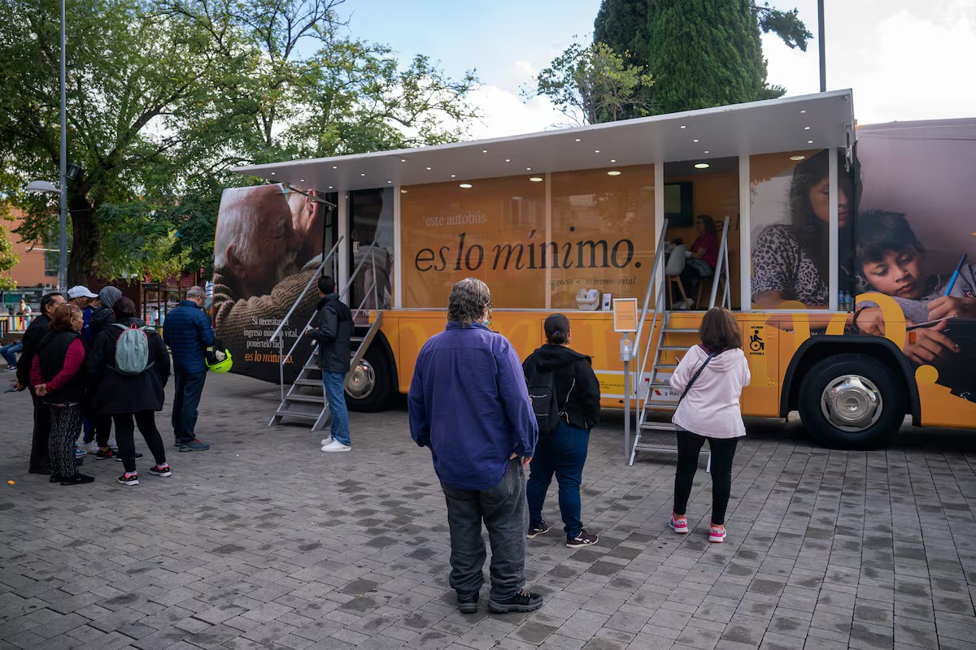
People waiting to board a bus providing information about the Minimum Living Income
(IMV) in Parla (Madrid), in October 2022.
ANDREA COMAS


JORGE GALINDO
July 10, 2025 - 5:45 a.m. CEST






3

In 2021, Spain demonstrated its awareness of the serious problem of poverty by passing the
most significant social policy of the past decade. Four years later, the Minimum Living Income (IMV) covers

400,000 households. However, a quarter of the Spanish population lives in households at risk of poverty or social exclusion. This gap reflects the structural limitations of the design of social policy and the Spanish economic model.



BREAKING NEWS

08:59 Breaking news on the U.S. and Israel’s war against Iran, live
| Trump backtracks and now says he will review the latest peace plan sent by Iran

To understand this, the first step is to break down the poverty or social exclusion risk indicator. A person is considered to be in this situation if they live in a household that meets at least one of these three conditions: monetary poverty (income below 60% of the median), severe material deprivation (lack of at least 7 out of 13 basic items), or low work intensity (household members of working age were employed for less than 20% of the possible time during the year).

The IMV, on the other hand, is designed as a basic safety net. Its thresholds are lower than those
refer to purely monetary poverty. Thus, when observing the gap between the two, many people argue
08:58 Seeing Eros Ramazzotti at 50 is a religious experience

08:38 National Lottery Mother's Day Special Drawing

07:56 The Miami Grand Prix is moved up three hours due to the risk of a thunderstorm

PARADORES TERRITORY

Puches, the delicious sweet crumbly pastries from La Mancha that are served for

A more generous UBI. Two points should be added to this reasonable request. First: AIReF reports that most eligible households do not even apply for it. The persistence of this finding should lead those of us who advocate for cash transfers to consider whether it might be worth rethinking the design of the policy. Second, we do not have one of the highest poverty rates among wealthy countries because our UBI is insufficient. In a market economy, the burden of reducing poverty falls on labor income, and Spain’s poverty rate is consistent with its extremely high unemployment.

Higher unemployment leads to greater poverty
Relationship between the percentage at risk of poverty or social exclusion and the unemployment rate, 2023

making the most of bread

MOST VIEWED

- The tiara that Cayetana de Alba sold to buy a horse for her son Cayetano was sold in the United States for 1.7 million euros

- Julio Sánchez, the former seminarian who sends flowers to Queen Letizia every Tuesday: “I’m not a monarchist, I’m a ‘Letizista’”

- Germany defends the strategic importance of the presence of U.S. troops at bases in the country following Trump’s withdrawal announcement

40% poverty

30

20

10

Germany Poland

Romania

Luxembourg

- Life under the fragile ceasefire in Tehran: “The war was terrifying, but what worries me today is just getting by”

- The body of Jesús Tavira, a witness in the CAM widow’s case, was found at the home of one of his employees in Alicante
Spain has the poverty rate
is in line with its unemployment rate



Unemployment
0
0 1 2 3 4 5 6 7 8

Eurostat, World Bank / EL PAÍS

Reducing unemployment has been a key driver in reducing poverty: between 2014 and 2024, the proportion of people in low-work-intensity households at risk of poverty or social exclusion fell from 13.4% to 6.3%.

Reducing structural unemployment is therefore a key priority. And here, the findings of the latest AIReF report are once again relevant: receiving the IMV reduces the likelihood of working by up to about 5 percentage points for those receiving the most generous benefits. Crucially, this effect persists even after the
introduction in 2022 of employment incentives that prevent a euro-for-euro reduction between wages and benefits.

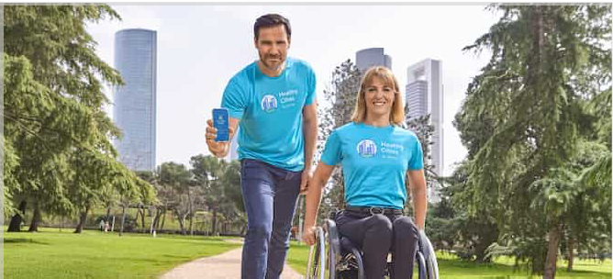

Join the 6,000-step challenge
Walk and turn your steps into healthy trees and cities

Poverty based solely on income remains, while material deprivation has risen over the past decade
% at risk of poverty or social exclusion depending on whether they experience only

monetary poverty, material deprivation (with or without monetary poverty), or low work intensity (with or without material deprivation)
4
5
6
7
8
9

201 | 10.7% |  | 6.1% |  |  | 13.4%
201 | 12.5% |  | 4.0% |  |  | 12.2%
201 | 12.2% |  | 4.9% |  |  | 11.7%
201 | 12.5% |  | 5.0% |  |  | 9.9%
201 | 13.4% |  | 5.4% |  |  | 8.3%
201 | 12.8% |  | 4.8% |  |  | 8.5%
202 | 13.0% |  | 6.1% |  |  | 7.8%
202 | 13.3% |  | 5.4% |  |  | 9.1%
202 | 13.6% |  | 5.7% |  |  | 6.8%
202 | 13.0% |  | 6.9% |  |  | 6.6%
202 | 13.0% |  | 6.6% |  |  | 6.3%

Monetary poverty is defined as having an income below 60% of the median. A person is at risk of poverty or social exclusion if they meet at least one of the following conditions: monetary poverty, deprivation in at least 7 out of 13 basic items, or low work intensity (household members of working age were employed for less than 20% of the total possible hours in the year).
0
1
2
3
4
Living Conditions Survey / EL PAIS

This underscores the need to rethink the policy, and especially this aspect of it. Rethink, not discard, because a unified transfer system remains both necessary and useful. For example, in contexts of high inflation. The data also show that the percentage of people at risk of poverty due to material deprivation has increased in recent years. Here, the use of the IMV has been a missed opportunity: we have preferred specific subsidies (transportation, rent, energy) or tax breaks instead of using the Income as the central channel, which would have been more effective, efficient, and fair.

But perhaps the most concerning trend is the rise in purely monetary poverty to 13%. This suggests that, although households may have moved out of other categories of poverty—especially low-work-intensity poverty—they continue to earn incomes below 60% of the national median. And, as evidence of this, the poverty rate among the employed has remained stagnant at 11% since 2008, while it has improved significantly among retirees (from
20% to 13%). Thus, Spain ranks third in the European Union in terms of in-work poverty.

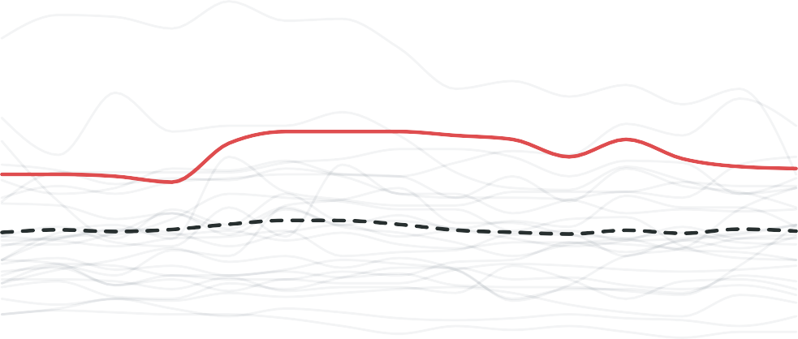
Spain: Third EU Country with the Most Working Poor
Trend in the relative poverty rate among the employed population
20%

15

11.2% Spain
10
8% EU-27

5

2010 2017 2024

Eurostat / EL PAIS

This is likely influenced by the fact that, despite a significant decline in the number of households with very low labor intensity, problems persist regarding inequality in hours worked and job stability. This is compounded by an average wage level that is actually quite low at the lower end of the distribution.

The persistence of in-work poverty in Spain highlights the need to increase incomes, focusing on the lowest-income deciles up to the median. Attempts to address this issue by raising the minimum wage have revealed limitations that stem precisely from the factors of working hours and labor intensity. The Bank of Spain estimated that the 2019 minimum wage increase raised the probability of job loss by about 3.2 percentage points in the long term and, when accounting for the number of hours worked, led to a drop of approximately 4 percentage points in the proportion of full-time workdays. The ISEAK Foundation obtained less negative results, but with significant indications: in the short term, they find no reduction in employment, but it does gradually emerge in the medium term, and work intensity is reduced by around
0.84 percentage points after one year: small, but it exists.

This leads us to the conclusion that the solution to our high relative poverty goes beyond the scope of demand-side decree-laws. If we repeat the correlation exercise between the risk of poverty and unemployment but using GDP per capita, Spain stands 5 percentage points above the poverty rate that would correspond to it based on its GDP per capita, suggesting distributional inefficiencies in the growth model.

Higher GDP per capita, lower poverty
Relationship between the % at risk of poverty or exclusion and GDP per capita, 2023

40 % poverty

Romania
30

Spain has a poverty rate higher than would be expected given its GDP per capita

20
Poland
Germany



10
GDP
0
0 10k 20k 30k 40k 50k 60k 7
Eurostat, World Bank / EL PAÍS

We could use a productivity boost at the lower end of the wage distribution. This means complementing demand-side policies with supply-side measures to narrow the income distribution from the bottom up. We could list the usual suspects here, from company size to production models. But I’m going to focus on one that would also help us tackle structural unemployment: investment in human capital for those at the bottom of the distribution.

To put it bluntly: only 1 out of every 40 euros from the NextGen Funds has gone to vocational training. We have the dual vocational training system, which hasn’t really taken off, despite evidence showing that it increases workdays by 25% and cumulative income by 42% during the first two years, according to the study by Samuel Bentolila and co-authors.
Vocational training is not typically viewed as a tool for combating the risk of poverty. But few things are better at driving long-term upward mobility for the half of the population with the lowest incomes in this country.

Jorge Galindo is deputy director of EsadeEcPol

ABOUT THE AUTHOR


Jorge Galindo
VIEW BIOGRAPHY


Guidelines ›
MORE INFORMATION
The minimum income reduces the
probability of working, but helps prevent precariousness
EMILIO SÁNCHEZ HIDALGO | MADRID
17% of households with employment and with
Children living in working poverty: “Working isn’t enough”
FRANCESCA RAFFO | MADRID
FILED UNDER

Economy · Living Wage · Poverty · Child Poverty · Employment ·
It adheres to the criteria of
If you are interested in licensing this
content, click here
More information
COMMENTS - 3
Receive our economic news newsletter exclusively for
subscribers.

Showcase Courses Online Courses Online Languages EL PAÍS Collections

Your calling deserves a future. Get trained and change lives.
Turn your passion for sweets into a career
Raise the standard of health and wellness advice

Turn your talent into your greatest asset.

